Elastic Collision in One Dimension

Example 1.
Solution: This is an elastic collision for a stationary target. Both momentum and kinetic energy are conserved. Thus, we have two equations for each conservation:
Solve the above system of equations for V1f and V2f:
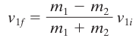, 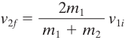
Plug in the numbers:
$v_{1f}=\frac{0.5-3.5}{0.5+3.5}×4=-3m/s$, $v_{2f}=\frac{2×0.5}{0.5+3.5}×4=1m/s$

Answer:
After collison, m1 is moving back with a speed of 3m/s, m2 is moving forward with a speed of 1m/s.

Practice Problems:
1. A 1055-kg van, stopped at a traffic light, is hit directly in the rear by a 715-kg car traveling with a velocity of 2.25 m/s. Assume that the transmission of the van is in neutral, the brakes are not being applied, and the collision is elastic. What are the final velocities of (a) the car and (b) the van?

Solution: This is an elastic collision problem with stationary target. The objest that was at rest before collision is m2, the one that was moving before collision is m1.

$m_{2}=1055 kg,$$m_{1}=715 kg,$$V_{01}= 2.25m/s,$$v_{02}=0,$
Again Both momentum and kinetic energy are conserved. Thus, we have two equations for each conservation just like the ones in Example 1 above and the solutions for the final velocities of the object has the same formula, plug in the numbers, we have:

$v_{1f}=\frac{715-1055}{715+1055}×2.25=-0.432m/s$, $v_{2f}=\frac{2×0.5}{0.5+3.5}×4=1.818m/s$

Answer:
After collison, the car is moving back with speed 0.432 m/s, m2 is moving forward with speed 1.818 m/s.

2. A cue ball (mass 0.165 kg) is at rest on a frictionless pool table. The ball is hit dead center by a pool stick, which applies an impulse of 1.50 N.s to the ball. The ball then slides along the table and makes an elastic head-on collision with a second ball of equal mass that is initially at rest. Find the velocity of the second ball just after it is struck.

First, we need to use impulse momentum theory to find velocity of the cue ball after being hit by the pool stick. This velocity will be the initial velocity of the cue ball to collide with a second ball, which is an elastic collision with both momentum and energy conserved.

Impulse equals the change of momentum for the cue ball. The cue ball was at rest, thus the initial momentum was 0.
$J=ΔP$ , $F⋅t=mv-0$, $1.5=0.165v-0$, $v=9.09m/s$

Once the elastic head-on collision with a second ball happens, both momentum and kinetic energy are conserved:
Solve the above system of equations for V1f and V2f:
, 
Here:
$m_{1}=0.165, v_{1i}= 9.09m/s$ , $m_{2}=0.165, v_{2i}= 0$
Solve:
$v_{2f}= \frac{2×0.165}{0.165+0.165}×9.09=9.09m/s$,
Since the two balls have the same mass, after elastic collision, they exchange their speeds.

Answer: The second ball after the collision is moving forward with a speed of 9.09 m/s.

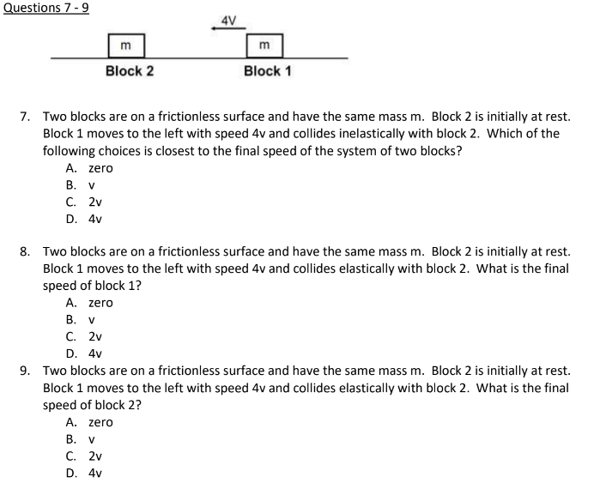

Answers: 7 B. 8 D. 9 A

Inelastic Collision and Perfectly Inelastic Collision
Example 2.
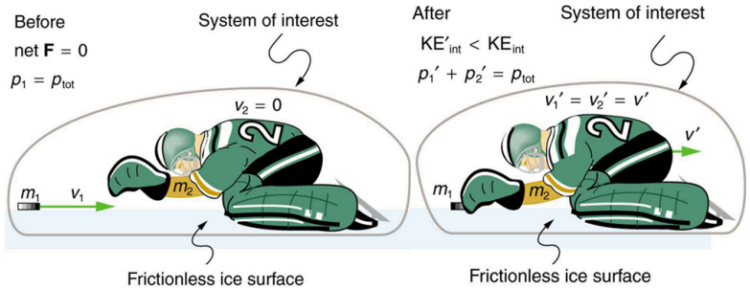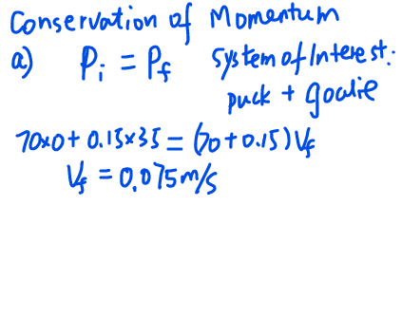
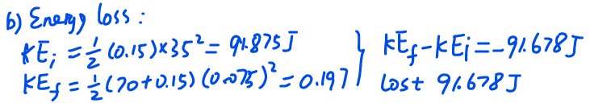

1. An object of mass 3M, moving in the +x direction at the speed $v_{0},$ collides with an object with M moving in the -x direction with speed ${2v}_{0}$. After the collision, the object with mass 3M moves in the -x direction at the speed of $v_{0}/5$ . Calculate the final magnitude and direction of the velocity of the object with the mass M. Determine if the collision was elastic or inelastic, and if it was inelastic, calculate the fraction of the initial kinetic energy dissipated in the collision.
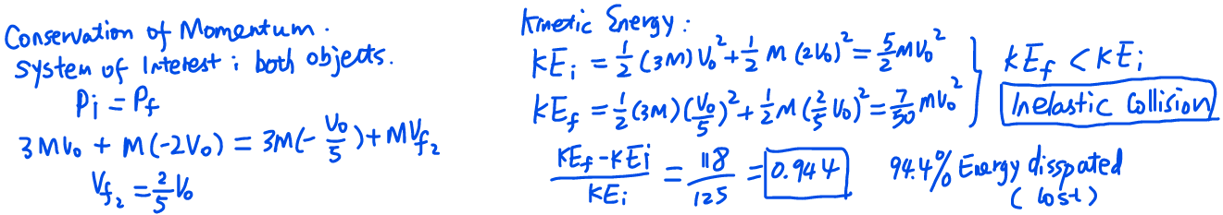

2. A ${1.00×10}^{4}$ kg train car moving due East at 20.0 meters per second collides with and couples to a ${2.00×10}^{4}$kg train car that is initially at rest. (a) What is the common velocity of the 2-car train after the collision? (b) What is the total kinetic energy of the 2-car train before and after the collision?
(c) Is momentum conserved before and after the collision?
(d) Is the kinetic energy conserved? What is the energy loss if energy is not conserved?
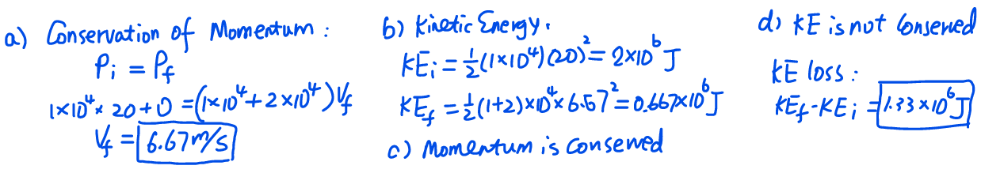

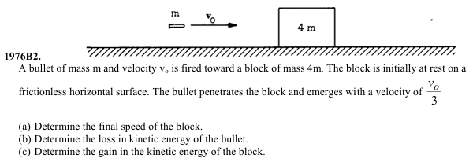
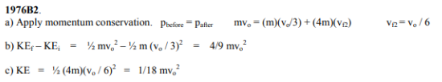

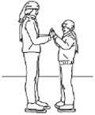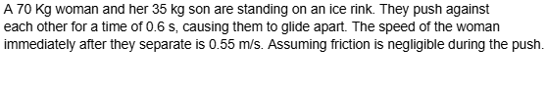
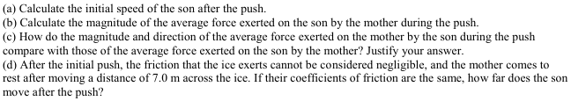
Solution:
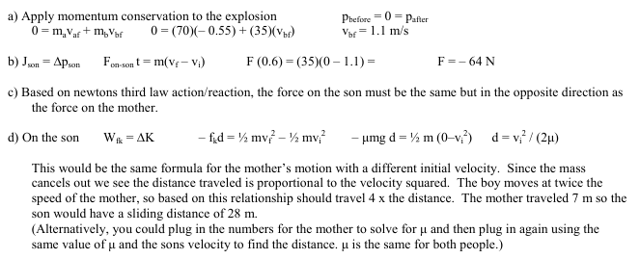

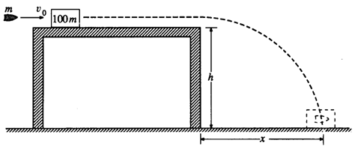
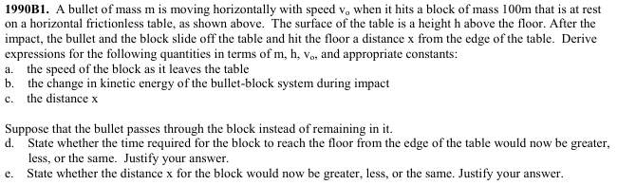
Solution:
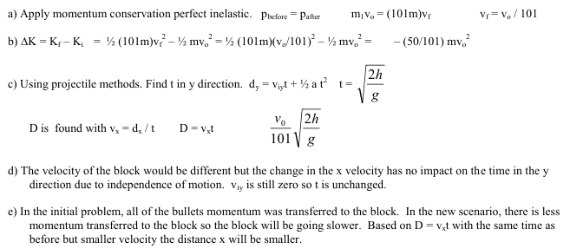

2008B1
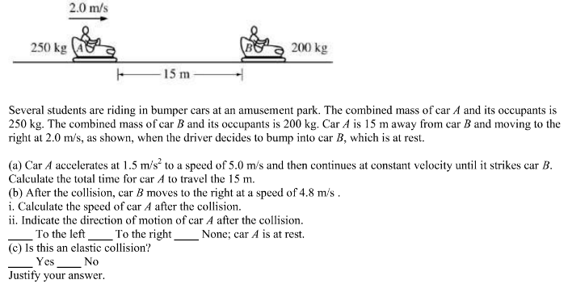

Solution:
